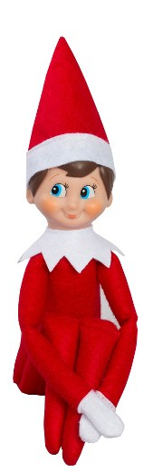 | Where you are going:  LAPLAND  Airport you are going to:  SANTA’S AIRPORT IN LAPLAND  Airport you fly from:  _________ | Name:  __________  You fly on:  ________ |   Please remember to bring your SPECIAL BOARDING PASS TO THE AIRPORT

